IT24101069 – Githminee M.G.S

PS Lab05



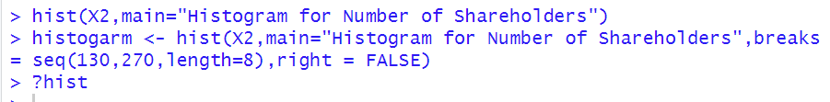

**Exercise**

(1)

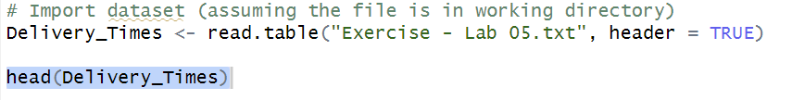

(2)

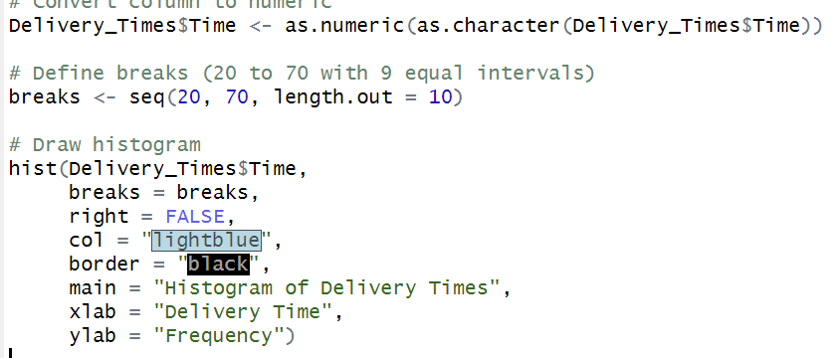

(3)

Comment on the shape of the distribution.

Bell shaped/Normal because the bars are all tall in the middle and tapper off

(4)

